Electronic Funds Transfer Switch Simulator

M9901802 Peter Gerhat

**Objective**

* Electronic funds transfer systems are used widely to process transactions that were submitted electronically (ATM, E-Commerce, card terminals)
* The network consists of **many nodes** which link payment **from initiator** (point where the transaction was initiated) **to bank server** (gives acceptance/rejection)
* Switch is component **in between**, its function is to **gather transactions** from multiple initiators and **forward them** to bank server according to a set of rules
* Transaction data have to be stored in a **shared database** which may be accessed by other nodes, furthermore any node in the system can **break down**
* The objective is to take advantage of **parallel transaction processing** on **switch level** to **maximize transaction throughput**, i.e. the effect of node breakdowns and processing delays should be minimal

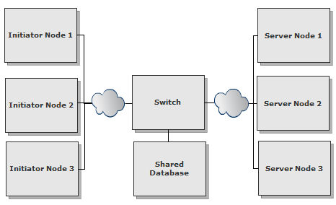

**Application**

* The intended use of the simulator is to test the overall system performance and experiment with different data layouts and routing algorithms

**Expected Outcome**

* Transaction simulator able to simulate workload in real environment

**Reference**

* Performability modeling of Electronic Funds Transfer Systems: <http://www.springerlink.com/content/57161k0456l72383/fulltext.pdf>
* ViSim: A simulation too for performance analysis of routing protocols

<http://www.sciencedirect.com/science/article/pii/S0895717710004267>

**Milestones**

* 3/27 – Project proposal
* 4/10 – Algorithm – describe which part of the program will be parallelized
* 5/8 – Serial version – the simulator program without parallel algorithm
* 6/5 – Parallel version – the final version of the program
* 6/12 – Final presentation